**Front-end Developer Work Challenge**

**First Step:**

I visited related website about prepr such as the video post on the youtube, official website of prepr and tried to understand the requirement of prepr.

And I think the target of prepr’s users is proof their skill by attending challenges, joining labs and finish their project.

Challenges are problems needed to solve.

Labs are teams and the members of the team will co-solve the same problem.

Projects are the result or the answer you answer to the problems.

**Second Step:**

*Explore Page*

The explore page is a page where we can find challenges, labs and Projects.

To improve user experience, we have understand the target of users to visit this page and what actions they want to take in this page.

In my opinion, in this page, the user want to find the challenges they are interested in and attend the challenges, and find the labs they are interested in and join the labs. And visit project finished by others.

Therefore, the main action of each challenge is “follow” and “view” and the main action of each lab is “join” and “view” and the main action of each projects is “vote” and “view”.

Thus, I think add “follow”/”join”/”vote” on this page will make user experience better.

On the other hand, the switch button will be sheltered by the header. Therefore, it is inconvenient for users to switch the type (Challenges/Labs/Projects) when they scroll to the bottom of this page. So, I put this button to the header which will guarantee the users can switch at any time and no need to scroll to the top of the page.

Finally, this is a explore page which means most of users want to explore more challenges/labs/projects within the same period of time. However, in the current page, users can see just two challenges on one screen and there are still a lot of blank areas without being used. And I think it will be better to let users see challenges/labs/projects on one screen.

So, I change it to three challenges/labs/projects per screen. And the cost is reducing the size of the picture.

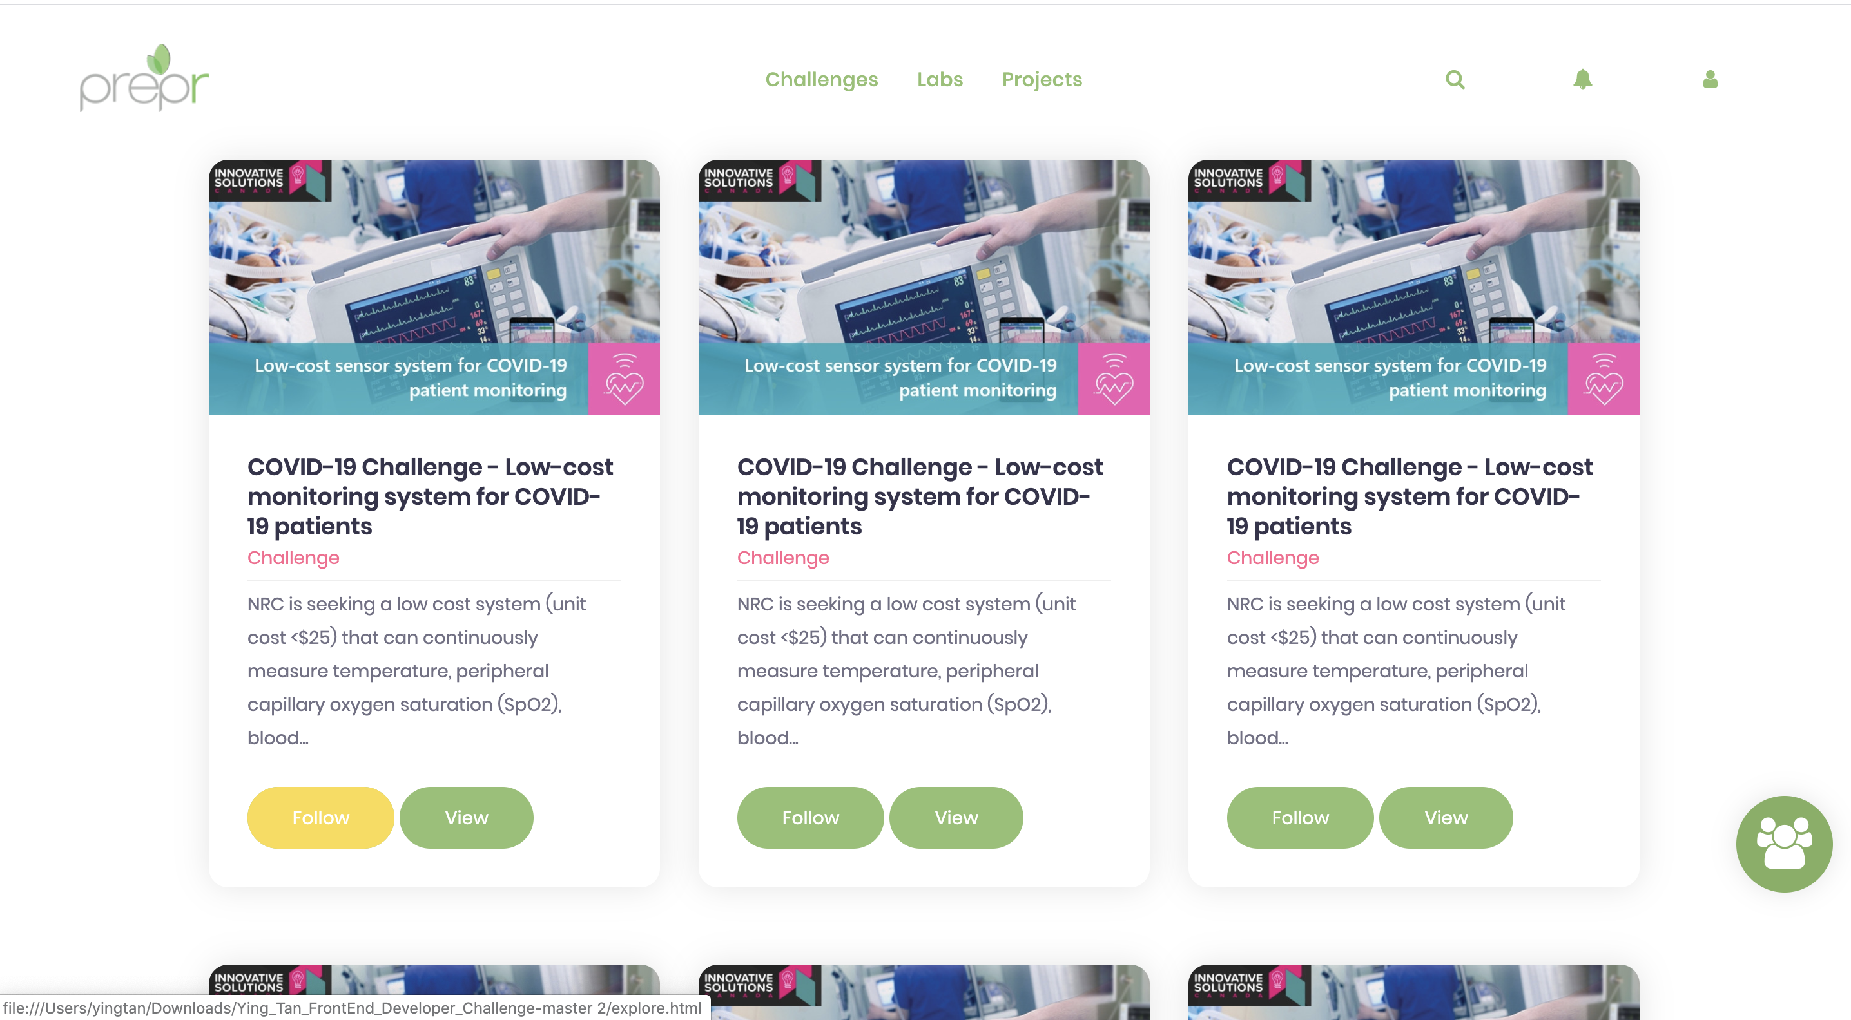

Figure explore page after changing